ASSIGNMENT 4

|  |  |
| --- | --- |
| Date | 28 Oct 2022 |
| Name | SRUTHY S |
| Team ID | PNT2022TMID42646 |
| Project Name | Smart Farmer – IoT Enabled Smart Farming  Application |

# QUESTION :-

Write code and connections in wokwi for ultrasonic sensor. Whenever distance is less than 100 cms send "alert" to IBM cloud and display in device recent events.

# CODE :-

## #include <WiFi.h>

#include <PubSubClient.h>

WiFiClient wifiClient;

String data3;

#define ORG "3yngbh"

#define DEVICE_TYPE "Assignment"

#define DEVICE_ID "1234"

#define TOKEN "234567890"

#define speed 0.034 #define led 14 char server[] = ORG ".messaging.internetofthings.ibmcloud.com"; char publishTopic[] = "iot-2/evt/shreedharen/fmt/json"; char topic[] = "iot-2/cmd/led/fmt/String"; char authMethod[] = "use-token-auth"; char token[] = TOKEN;

char clientId[] = "d:" ORG ":" DEVICE_TYPE ":" DEVICE_ID;

PubSubClient client(server, 1883, wifiClient);

const int trigpin=5; const int echopin=18;

String command;

String data="";

long duration; float dist; void setup()

{

Serial.begin(115200); pinMode(led, OUTPUT); pinMode(trigpin, OUTPUT); pinMode(echopin, INPUT); wifiConnect(); mqttConnect();

} void loop() { bool isNearby = dist < 100; digitalWrite(led, isNearby);

publishData(); delay(500);

if (!client.loop()) { mqttConnect();

}

}

void wifiConnect() {

Serial.print("Connecting to "); Serial.print("Wifi"); WiFi.begin("Wokwi-GUEST", "", 6); while (WiFi.status() != WL_CONNECTED) { delay(500);

Serial.print(".");

}

Serial.print("WiFi connected, IP address: ");

Serial.println(WiFi.localIP());

} void mqttConnect() { if (!client.connected()) {

Serial.print("Reconnecting MQTT client to "); Serial.println(server); while (!client.connect(clientId, authMethod, token)) { Serial.print("."); delay(500);

}

initManagedDevice();

Serial.println();

}

} void initManagedDevice() { if (client.subscribe(topic)) {

// Serial.println(client.subscribe(topic));

Serial.println("IBM subscribe to cmd OK"); } else {

Serial.println("subscribe to cmd FAILED");

} } void publishData()

{ digitalWrite(trigpin,LOW); digitalWrite(trigpin,HIGH); delayMicroseconds(10); digitalWrite(trigpin,LOW); duration=pulseIn(echopin,HIGH); dist=duration*speed/2; if(dist<100){

String payload = "{\"Alert Distance\":"; payload += dist; payload += "}";

Serial.print("\n");

Serial.print("Sending payload: "); Serial.println(payload);

if (client.publish(publishTopic, (char*) payload.c_str())) {

Serial.println("Publish OK");

}

}

if(dist>100){

String payload = "{\"Distance\":"; payload += dist; payload += "}";

Serial.print("\n");

Serial.print("Sending payload: "); Serial.println(payload);

if(client.publish(publishTopic, (char*) payload.c_str())) {

Serial.println("Publish OK");

## }else {

Serial.println("Publish FAILED");

}

}

}

# OUTPUT:-

i) When distance greater than 100 cm

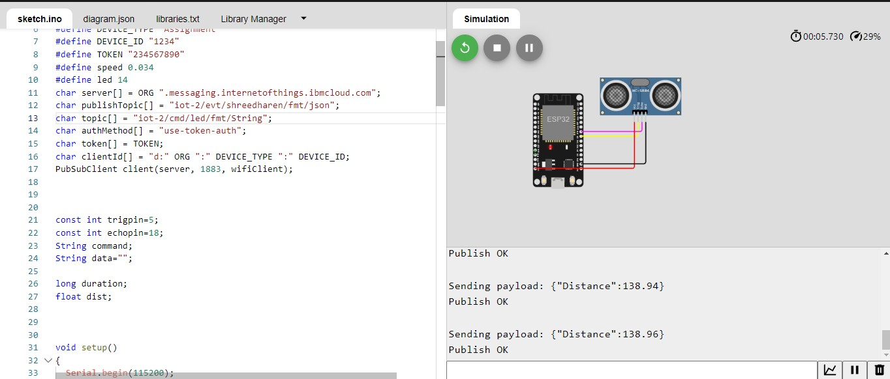

# IBM RECENT EVENTS

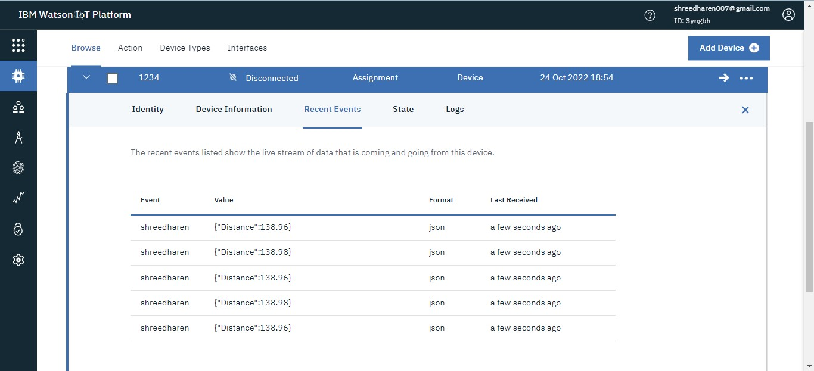

ii) When distance less than 100

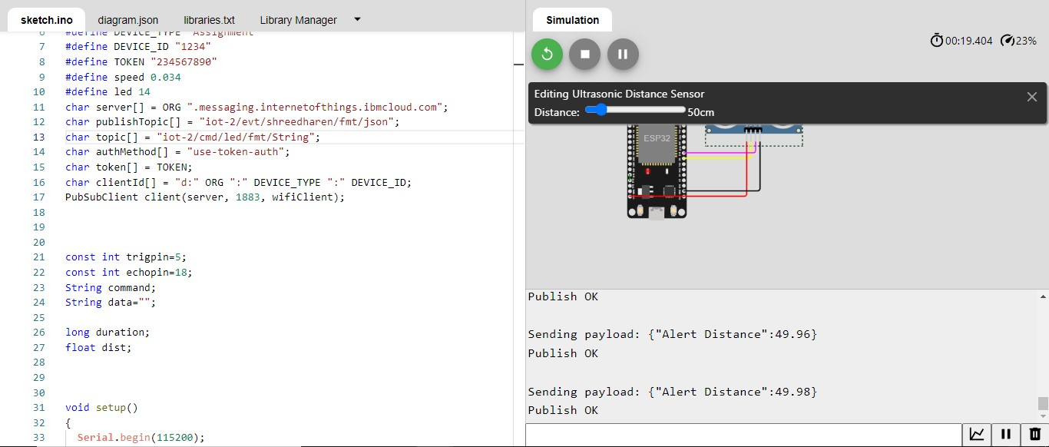

# IBM RECENT EVENTS

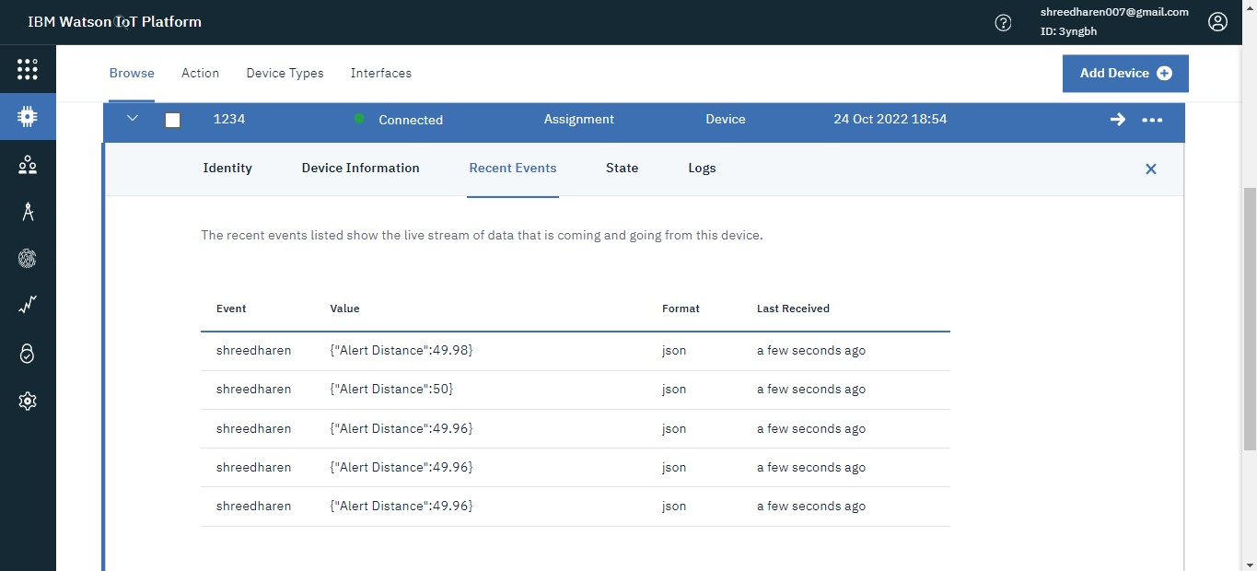

# WOKWI LINK -

<https://wokwi.com/projects/346405970317935188>